North Lincolnshire Council
Daily Event Analysis
18th October 2010

Overview
The Low Santon TEOM measured a daily mean PM₁₀ concentration of 77µg/m³ on Monday 18th October 2010 exceeding the allowed 50µg/m³ as a daily mean. The Dawes Lane Coke Oven (DLCO) Osiris measured a daily PM₁₀ concentration of 71μg/m³ on Monday 18th October 2010 also exceeding the allowed 50μg/m³ as a daily mean. A check of the data has revealed that the PM₁₀ concentrations were above the 50μg/m³ threshold between 07:00 and 19:00 at both the Low Santon TEOM and the DLCO Osiris. The average PM₁₀ concentration for this time period at the Low Santon TEOM was 115μg/m³ and 97μg/m³ at the DLCO Osiris. There was a significant peak in the PM₁₀ concentration at the DLCO Osiris at 07:45 measuring 290μg/m³, this peak will be commented on separately.

Met Conditions
Consistent SW winds were observed throughout the day. The wind within the 12 hour period of focus ranged between 235° and 270°. Wind speeds averaged at 3.5 m/s. Rain was measured in the evening in to the early hours of Tuesday morning.
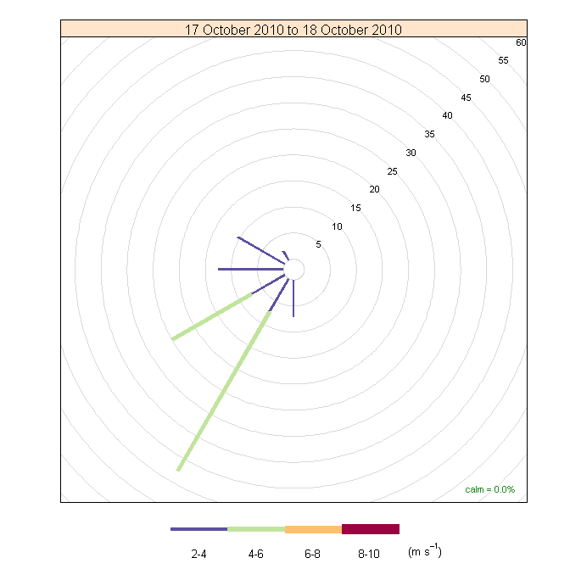

Episode Wind Range 07:00 to 19:00

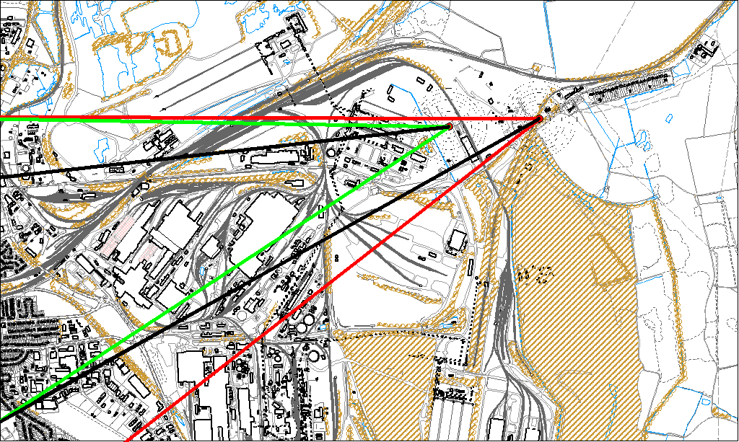

Potential Sources
The above map shows the Low Santon TEOM (indicated by the red lines) and the DLCO Osiris (indicated by the green). The black lines within the red and green wind ranges shows the wind direction of the highest concentrations recorded during the 12 hour period of focus. The highest concentration at the DLCO Osiris did not take into account the peak in concentration experienced at 07:45.

As both the Low Santon TEOM and the DLCO Osiris exceeded the 50μg/m³ the source affecting the DLCO Osiris is also likely to be affecting the Low Santon TEOM.

The likely areas include;

- Dawes Lane Coke Ovens
- The Redbourn Steel Stocking Area
- Tarmac (at the TEOM)

The black line indicates the highest measured concentration during this period. For the DLCO Osiris this runs through the Dawes Lane Coke Ovens. The black indicating the highest measured concentration recorded at the Low Santon TEOM runs through both the Tarmac site and the NW tip of the Redbourn Steel Stocking Area.

Peak at DLCO Osiris

Additionally there was a significant peak in PM₁₀ concentration at the DLCO Osiris which is highlighted on the graph below. This peak occurred at 07:45 and measured 290μg/m³.

07:45 DLCO Osiris

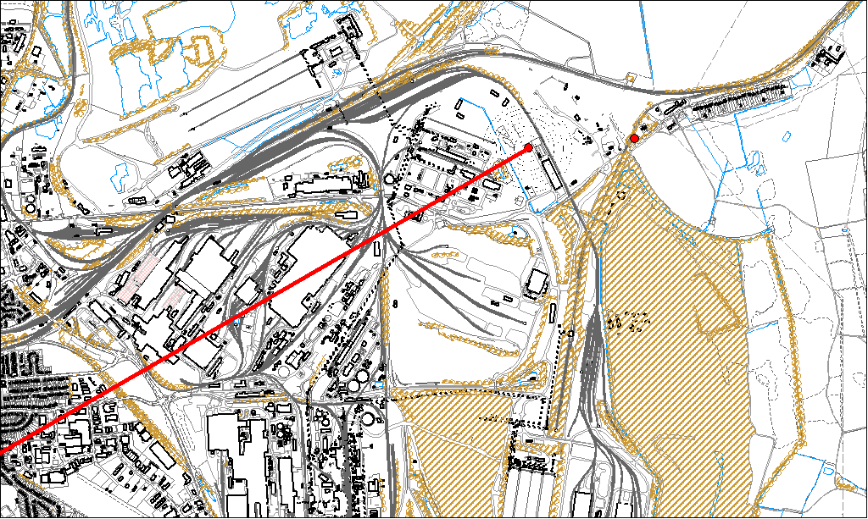

Potential sources

The red line on the above map and the spike on the graph show the highest concentration experienced at the DLCO Osiris. This line runs through the Dawes Lane Coke Ovens Site.

